

**Graded Lab Assignment 4 – CSF416_Web Technologies and Applications, ODD Sem, 2024**

# Student Name: Muskan Kumari ID: 1000016871 Major: B.tech IT

**Instructions**

* There are **2** questions in this assignment.
* Email/paper/other modes of submissions will not be accepted.
* Upload a word **version** of this document.
* Assignment submitted after due date will not be evaluated and a score of zero will be awarded.
* Plagiarism may lead to award of zero marks.

**Due Date: 12pm, 5th November 2024**

**Submitting this Assignment**

You will submit (upload) this assignment in MS Teams. Name this document as GLA1_AJPODD2024_John_Doe.doc in case your name is John Doe, and this graded lab assignment is 1 of course whose acronym is AJP, and offered in ODD 2024. Paste your code after each question, paste the screenshot of output, save and upload the document.

**Grading Scheme:** This assignment has5 marks.

**Question 1:**

**Session-Based Visit Counter**

* Create a JSP page that keeps track of how many times a user has visited the page during the current session.
* Use session management to store the visit count and display it on the page.

# CODES

<html>

<head>

<title>Session-Based Visit Counter</title>

</head>

<body>

<h2>Welcome to the Visit Counter Page!</h2>

<p>Refresh the page to see the visit count increase!</p>

</body>

</html>

<!DOCTYPE html>

<html>

<head>

<title>Visit Counter</title>

</head>

<body>

<h1>Welcome to the Visit Counter Page!</h1

Integer visitCount = (Integer) session.getAttribute("visitCount"); if (visitCount == null) { visitCount = 1;

} else {

visitCount++;

}

session.setAttribute("visitCount", visitCount);

<p>You have visited this page <%= visitCount %> times during this session.</p>

</body>

</html>

# OUTPUT

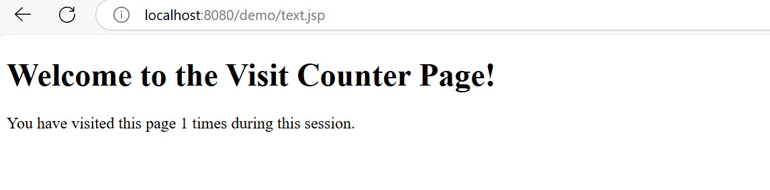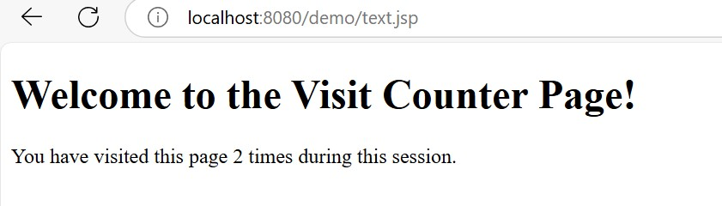

**Question 2:**

**To-Do List with Sessions**

* Develop a JSP page where users can add items to a to-do list.
* Store the list in session data and display it on the page, allowing users to see their list as they add items.

# CODES

<!DOCTYPE html>

<html>

<head>

<title>To-Do List with Session</title>

</head>

<body>

<h2>Your To-Do List</h2>

<!-- Form to add a new item to the to-do list -->

<form action="TodoList.jsp" method="post"> <label for="item">Add a new item:</label>

<input type="text" id="item" name="item" required>

<button type="submit">Add Item</button>

</form>

<!-- Display the current to-do list -->

<h3>Items in Your To-Do List:</h3>

<ul>

String item : todoList

</ul>

</body>

</html>

# OUTPUT

